Design and Implementation of a

Mobile Application that Connects Consumers to Nearby Vendors

**BY**

**Hadiza Aliyu**

**BU/22A/IT/6545**

**IN PARTIAL FULFILMENT OF THE REQUIREMENT FOR THE AWARD OF BACHELOR OF SCIENCE IN SOFTWARE ENGINEERING, FACULTY OF COMPUTING AND APPLIED SCIENCE, BAZE UNIVERSITY, ABUJA.**

**January, 2025**

# DECLARATION

I hereby declare that this research project has been written by me under the supervision of Dr. Usman Bello Abubakar. The work has been presented in any previous research for the award of B.Sc degree to the best of my knowledge. The work is entirely mine and I accept the sole responsibility for any errors that might be found in the work, while the reference to publish material have been duly acknowledged.

__________________________ _____________________

Hadiza Aliyu Date

BU/22A/IT/6545

**APPROVED BY**

_____________________

**Head of Department,**

Department of Computer Science

# CERTIFICATION

This project entitled “Design and Implementation of a mobile application that connects consumers to nearby vendors” meets the requirements governing the award of Bachelor of Science in Software Engineering in Baze University, Abuja.

# APPROVAL

# This is to certify that the research work title Design and Implementation of a mobile application that connects consumers to nearby vendors by Hadiza Aliyu with BU/22A/IT/6545 has been approved by the Department of Computer Science, Faculty of Computing and Applied Science, Baze University, Abuja, Nigeria.

By

Dr Usman Bello Abubakar

Supervisor Date

Dr Usman Idris Abubakar

Head of Department Date

Assoc Prof Chandrashekar V Uppin

Dean, Faculty of Computing and Applied Science Date

Prof Choji Davou Nyap

External Examiner Date

# DEDICATION

# ACKNOWLEDGEMENT

# *ABSTRACT*

# TABLE OF CONTENTS

**DECLARATION** 2

**CERTIFICATION** 3

**APPROVAL** 4

**DEDICATION** 5

**ACKNOWLEDGEMENT** 6

**ABSTRACT** 7

**TABLE OF CONTENT** 8

**LIST OF TABLES** 9

**LIST OF FIGURES** 9

**CHAPTER 1: INTRODUCTION** 10

1.1 Overview 10

1.2 Background and Motivation 10

1.3 Statement of the Problem 11

1.4 Aims and Objectives 11

1.4.1 Aims 12

1.4.2 Objectives 12

[1.5](https://docs.google.com/document/d/1LIHZjZ8lUFsSwqAyPIMEoezMQOm4kFFm/r/edit/edit#heading=h.z337ya)  Significance of the Project 12

1.6 Project Risks Assessment 13

1.7 Scope/Project Organization 13

1.7.1 Scope 14

1.7.2 Project Organization 15

**CHAPTER 2: LITERATURE REVIEW 18**

2.1 Introduction 18

2.2 Historical Overview 18

2.3 Related Work 19

2.4 Summary 24

# LIST OF TABLES

**Table 1.1: Project Risk Assessment**

# LIST OF FIGURES

**Figure 2.1 OfferUp Mobile App**

**Figure 2.2 Facebook Marketplace Mobile App**

**Figure 2.3 Amazon Mobile App**

**Figure 2.4 Jumia Mobile App**

# CHAPTER ONE

# INTRODUCTION

1.1 Overview

The FindNearMe mobile application is designed to bridge the gap between local buyers and sellers. The primary objective of the app is to provide a seamless, efficient, and secure platform for discovering, purchasing, and selling items within local communities. This not only promotes environmental sustainability by encouraging local transactions but it also boosts local commerce by supporting small businesses. This can significantly aid in addressing Nigeria's declining economic growth.

By leveraging advanced technologies such as AI-powered image recognition and real-time mapping services, this system aims to apply a geotagging based approach to retail. The key features of this application include; Image Recognition and Matching for Product Search, Location-Based Search & Interactive Maps, Seller and Buyer Accounts, Seller Profiles and In-App Messaging which will be further discussed in this report.

1.2 Background and Motivation

In recent years, the global landscape of commerce has witnessed a significant shift towards digital platforms and online marketplaces. According to eMarketer (2021), global e-commerce sales reached $4.28 trillion in 2020 . While this transformation has brought convenience and accessibility to consumers worldwide, it has also posed challenges for local businesses, particularly small and medium-sized enterprises (SMEs) in developing countries like Nigeria. These businesses often struggle to compete with larger, more established online retailers, resulting in decreased visibility and sales opportunities.

The motivation behind the FindNearMe app stems from the need to support local commerce, empower small businesses, and enhance the overall shopping experience for consumers in Nigeria. Consumers frequently face difficulties in finding specific items locally, leading to time-consuming searches. The app simplifies and expedites this process by enabling users to find products through AI-powered image recognition and detailed local listings.Long-distance shipping associated with online shopping contributes to carbon emissions and environmental degradation. FindNearMe encourages the purchase of locally produced goods, which often have a smaller carbon footprint compared to imported items. Small businesses in Nigeria often struggle with limited visibility and reach. FindNearMe provides a platform for these businesses to showcase their products to a broader local audience, helping them compete with larger retailers. By promoting local businesses, the app contributes to economic growth and job creation, fostering a thriving local economy.

The proposed project aims to design and develop the FindNearMe app, which will use AI-powered image recognition and real-time mapping to enhance local business visibility, simplify product discovery for consumers while promoting sustainable practices and fostering community engagement.

1.3 Statement of the Problem

Despite the growing digital landscape and increased smartphone penetration in Nigeria, local commerce faces several critical challenges. Consumers still find it difficult to locate specific items locally, as noted by a Nigerian Communications Commission survey where 60% of consumers cited difficulties in finding local products.

The rise of online shopping has also increased long-distance shipping, contributing to higher carbon emissions and environmental degradation. Additionally, the lack of a platform to foster local interactions and collaborations results in disconnected communities and underutilized local economies.

The FindNearMe app aims to address these challenges by enhancing visibility for local businesses, simplifying product discovery for consumers, promoting sustainable practices, and fostering community engagement. By leveraging AI-powered image recognition and real-time mapping services, the app provides a seamless platform for local commerce, contributing to Nigeria's socio-economic development.

1.4 Aims and Objectives

**1.4.1 Aims**

The Aim of this project is to design and implement a user-friendly mobile application that connects consumers to nearby vendors.

**1.4.2 Objectives**

1. To integrate AI-powered image recognition to allow users to scan items and find similar products.
2. To implement real-time mapping features to provide users with directions to local sellers.
3. To integrate geotagging functionality to accurately connect buyers to nearby sellers.
4. To develop an in-app messaging system for seamless communication between buyers and sellers.
5. To design and implement a review and rating system to build trust and reliability among users.

1.5 Significance

The FindNearMe mobile application holds significant potential to transform local commerce in Nigeria by providing a comprehensive solution that benefits both consumers and local businesses. Its significance lies in its ability to make local shopping more convenient, environmentally friendly, and supportive of community growth and development.

1. **Improving Consumer Convenience:** The AI-powered image recognition feature allows consumers to find products easily by simply scanning items, eliminating the need for extensive searches and making shopping more convenient. Integration with mapping services like Google Maps, along with geotagging, provides users with accurate directions to seller locations, ensuring they can quickly and easily find what they are looking for.The app also provides comprehensive product information, reviews, and ratings, helping consumers make informed purchasing decisions.
2. **Empowering Local Businesses:** The app offers a platform for local businesses to showcase their products to a wider audience, which helps them overcome the limitations of traditional brick-and-mortar stores. By allowing sellers to upload images and details of their products, the app serves as an effective marketing tool that can attract more customers and drive sales. Supporting local businesses through the app contributes to the overall economic growth of the community by creating jobs and increasing local revenue.
3. **Promoting Sustainable Practices:** By encouraging local transactions, the app helps reduce the need for long-distance shipping, thereby lowering carbon emissions associated with transportation. Furthermore, promoting the purchase of locally produced goods supports sustainable consumption patterns and reduces the environmental impact of goods distribution.
4. **Strengthening Community Ties:** The app fosters trust between buyers and sellers through secure transactions, ratings, and reviews, creating a trustworthy marketplace. By facilitating local transactions, the app promotes interactions within the community, contributing to stronger social ties and community support. In addition, supporting local businesses helps retain money within the community, which can be reinvested in local infrastructure and services.
5. **Leveraging Advanced Technologies:** The use of advanced AI technologies for image recognition enhances the user experience by making product discovery quick and intuitive. Accurate geotagging and integration with mapping services improve the reliability and accuracy of search results, enhancing the overall usability of the app.

1.6 Project Risks Assessment

These are a few risks that can come up in the advancement of this project and recommended ways the risk may possibly be avoided.

**Table 1.1: Risk Assessment of the Project and Mitigation Strategies**

| Risk | Risk Mitigation |
| --- | --- |
| Low User Adoption: The app might fail to attract a sufficient number of users or users may hesitate accommodating the app. | Conducting market research to understand user needs and preferences and creating a user-friendly interface and a seamless user experience. Develop a comprehensive marketing strategy that includes online campaigns, partnerships with local businesses, and promotions. Implement a feedback mechanism to gather user input and continuously improve the app. |
| System Integration Failures: Might encounter difficulty in integrating AI, image recognition, geotagging, and mapping technologies seamlessly. | Conduct thorough research and testing of APIs and software development kits (SDKs) before full integration. Furthermore, integrate components incrementally and test each integration thoroughly before moving on to the next. Also implement unit testing, integration testing, and system testing to catch and resolve issues early. |
| Data privacy and security breaches involving unauthorized access, use, or disclosure of sensitive user data. | Use strong encryption methods to protect data at rest and in transit. Ensure compliance with data protection regulations such as GDPR and NDPR. Also educate users about best practices for protecting their accounts, such as using strong passwords and recognizing phishing attempts. |
| Scalability issues may arise when the application grows and is unable to handle increased load and user traffic. | Design the application with scalability in mind. Utilize cloud services that can easily scale up resources based on demand (e.g., AWS, Google Cloud, Azure). Conduct regular performance and load testing to ensure the application can handle increased traffic. |
| Intellectual property (IP) issues may arise when there are disputes over the ownership, usage, or rights to the app’s technology, content, or branding. This can lead to legal challenges and potentially significant financial losses. | Conduct thorough research to ensure that all software components, technologies, and content used in the app are properly licensed and do not infringe on existing IP. Draft clear agreements with all stakeholders regarding IP ownership and usage rights. |

1.7 Scope/ Project Organization

This document outlines the activities and processes involved in developing a mobile application designed to connect consumers with nearby vendors. The app aims to enhance the shopping experience for consumers while boosting the visibility of local vendors. The scope and organization of the project are outlined as follows:

1.7.1 Scope

The scope of the FindNearMe app project encompasses the development, deployment, and maintenance of a mobile application designed to connect buyers with local sellers through advanced technologies. The app will facilitate local commerce by providing features such as AI-powered image recognition, geotagging and mapping.

**Key Functionalities include:**

1. Creation of separate accounts for buyers and sellers. As well as profile management for both account types.
2. Product listings, categorization and geotagging. Sellers can also upload pictures and details of their products.
3. AI-Powered image scanning and matching of scanned products with listings from local sellers.
4. Reservation of items for a limited time, so buyers can reserve items they want before they get to the seller's location.
5. Integration with mapping services like Google Maps to provide directions to seller locations, and display nearby sellers on a map.
6. Allowing buyers to rate and review sellers and displaying ratings and reviews on seller profiles.
7. Real-time notifications for new messages and nearby product listings.

1.7.2 Project Organization

The report consists of five chapters as outlined below:

Chapter 1: provides a general overview of what the whole project is all about such as background and motivation, statement of the problem, aims and objectives, significance of the project, and project risk assessment.

Chapter 2: provides Literature Review, introduction, historical overview, related work and summary.

Chapter 3: This chapter depicts the Requirement Analysis and Design.

Chapter 4: This includes the implementation and testing of the project’s components

Chapter 5: Discussion, conclusion, and recommendation are in this chapter. Finally the reference and appendices are in the last part of the report.

# Chapter 2

# Literature Review

# 

2.1 Introduction:

The chapter provides a comprehensive overview of existing research, theories, and applications relevant to the FindNearMe app. It begins with the historical development of mobile commerce, the integration of image recognition in online shopping apps, the use of geotagging and mapping technologies, and related works that have addressed similar problems. The objective is to identify gaps in current knowledge and establish the theoretical and practical foundations for the FindNearMe app.

2.2 Historical Overview:

The development of mobile commerce has revolutionized consumer behavior and the retail industry. The rise of online shopping began in the early 1990s with the advent of the internet and the establishment of pioneering e-commerce platforms like Amazon and eBay. Amazon, which started as an online bookstore in 1994, rapidly expanded its product offerings and established itself as a dominant force in the retail sector (Kotha, 1998). The company's innovative approach to online retailing, including features such as personalized recommendations and customer reviews, set the standard for future e-commerce platforms. Online shopping has grown steadily in popularity in recent years. In 2021, global online retail sales amounted to almost five trillion U.S. dollars, a figure expected to exceed seven trillion U.S. dollars by 2025 (Coppola,2024).

During the 2000s, the proliferation of broadband internet significantly enhanced the accessibility and efficiency of online shopping. This era also witnessed the rise of digital marketplaces like Alibaba in China, which broadened the scope of e-commerce by connecting buyers and sellers on an unprecedented scale. Alibaba’s success, particularly with platforms like Taobao, demonstrated the potential of e-commerce in emerging markets and highlighted the growing importance of online shopping in global retail .

The late 2000s and early 2010s marked a significant shift with the advent of smartphones and the development of mobile commerce (m-commerce). Mobile applications like Amazon’s mobile app and Alibaba’s Taobao app provided users with a seamless shopping experience, integrating features such as personalized recommendations, push notifications, and one-click purchasing. According to Statista’s Market Insights, mobile e-commerce sales reached $2.2 trillion in 2023 and now make up 60 percent of all e-commerce sales around the world.(Buchholz, 2023).

Artificial Intelligence (AI) has played a crucial role in enhancing the functionality and user experience of mobile commerce applications. In accordance to Sachdev (2024), 85% of consumers identify visual information as the most influential factor in their purchasing decisions, while retailers utilizing this technology saw a 48% increase in order value. AI-powered image recognition technology, such as Google Lens and Amazon's visual search, allows users to search for products using images instead of text, improving the accuracy of search results and providing a more intuitive shopping experience .

Geotagging and mapping technologies have also evolved significantly, becoming integral components of many mobile applications. Google Maps, launched in 2005, revolutionized the way users navigate and interact with geographic data. In an article by the vice president of engineering, google maps, Reid (2020) titled “A look back at 15 years of mapping the world”, it stated that Google Maps is used by more than 1 billion people all over the world every month and more than 5 million websites and apps use Google Maps Platform every week. The integration of GPS technology enabled real-time location tracking, making it possible to provide personalized recommendations based on the user's location . Applications such as Yelp and TripAdvisor have leveraged these technologies to offer location-specific recommendations and reviews, enhancing the relevance and utility of their services.

These technological advancements in online shopping, AI, and geotagging have laid the groundwork for the development of innovative applications like FindNearMe. By leveraging AI-powered image recognition, real-time mapping, and geotagging technologies, FindNearMe aims to bridge the gap between local buyers and sellers, enhancing local commerce and fostering community engagement.

2.3 Related Work

1. **OfferUp**: OfferUp is a mobile marketplace that allows users to buy and sell items locally. Users can list items for sale by uploading pictures, setting a price, and providing a brief description. The platform focuses on facilitating peer-to-peer transactions within local communities, providing in-app messaging for communication between buyers and sellers. But OfferUp is only available to United States residents. 

Figure 2.1 OfferUp Mobile App

**Pros:**

1. **Focus on Local Commerce:** Encourages buying and selling within the local community.
2. **Simple Interface:** Easy-to-use platform that makes it quick to list and browse items.
3. **In-App Messaging:** Secure communication between buyers and sellers helps to coordinate transactions safely.

**Cons:**

1. **Limited to only US residents:** The app is not available to people outside the US.
2. **Quality Control Issues:** Inconsistent listings and potential scams are common, with limited verification processes.

#### Facebook Marketplace: Facebook Marketplace is an online platform embedded within the Facebook app that allows users to buy and sell items within their local area. Nigerian consumers can use Facebook Marketplace to find a variety of products, from electronics to household goods. The platform benefits from Facebook’s large user base, making it easier to find buyers and sellers nearby. However, the integration with social media profiles may raise privacy concerns.

Figure 2.2 Facebook Marketplace Mobile App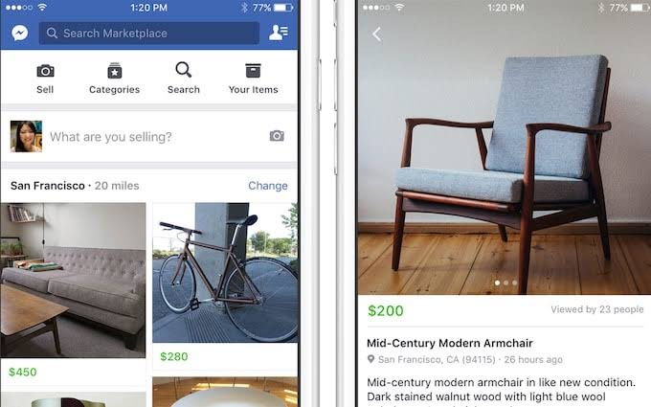

**Pros:**

1. Large User Base: With millions of Facebook users in Nigeria, the Marketplace has a broad reach, increasing the chances of finding buyers or sellers.
2. Ease of Access: The platform is easily accessible through the existing Facebook app, with no need for additional downloads.
3. Social Connectivity: Mutual friends and connections can enhance trust between buyers and sellers.

**Cons:**

1. Limited Security Features: There are minimal safety measures, which can lead to scams or fraud.
2. Privacy Concerns: Users may be hesitant to link transactions with their personal social media profiles.
3. No Specialized Customer Support: The platform lacks tailored support for Nigerian consumers, which can lead to unresolved issues.

#### Amazon: Amazon is a global e-commerce giant that offers a vast selection of products across various categories, including electronics, fashion, and home goods. Nigerian consumers can access Amazon’s offerings, but they often face challenges related to shipping costs and delivery times. While Amazon provides advanced features like AI-driven product recommendations and customer reviews, its focus is primarily on global commerce rather than local transactions.

Figure 2.3 Amazon Mobile App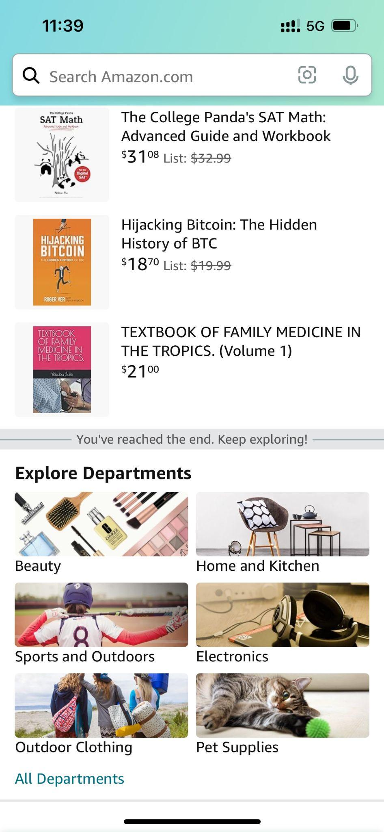

**Pros:**

1. Extensive Product Range: Offers an enormous variety of products, often unavailable locally.
2. Advanced Features: Includes AI-powered recommendations, customer reviews, and seamless payment options.
3. Trusted Brand: Amazon’s global reputation for reliability and customer service is a significant advantage.

**Cons:**

1. High Shipping Costs: International shipping to Nigeria can be expensive and time-consuming.
2. Customs and Import Duties: Products shipped from abroad may incur additional costs and delays due to customs regulations.
3. Limited Local Focus: Amazon does not prioritize local sellers or products, which may not support the Nigerian economy as effectively.

4. **Jumia:** Jumia is an e-commerce platform that caters specifically to African consumers, offering a wide range of products, including electronics, fashion, and household items. The platform is tailored to the needs of the Nigerian market, with localized services such as cash on delivery and various payment options through JumiaPay. Jumia also runs frequent promotions, making it a popular choice for budget-conscious shoppers.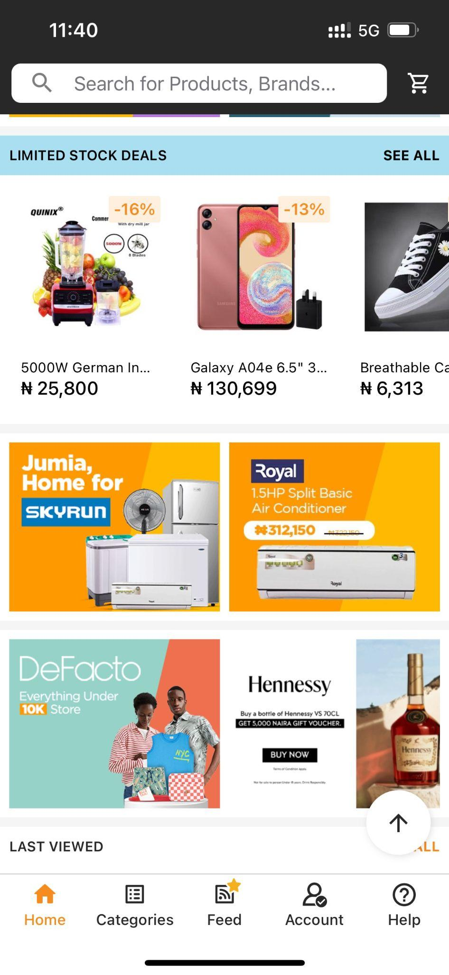

Figure 2.4 Jumia Mobile App

**Pros:**

1. Localized Services: Jumia is designed with Nigerian consumers in mind, offering payment options like cash on delivery and localized customer support.
2. Wide Product Range: Provides a broad selection of products, including both local and international brands.
3. Frequent Promotions: Regular discounts and deals make it an attractive platform for shoppers in Nigeria.

**Cons:**

1. Delivery Challenges: Inconsistent delivery times and logistics issues are common, particularly in remote areas.
2. Quality Control: The platform has faced criticism for the quality of some products and discrepancies between product descriptions and actual items.
3. Customer Service Issues: Users often report difficulties in resolving issues related to returns and refunds.

FindNearMe is designed specifically to address the unique challenges faced by Nigerian consumers in the local commerce landscape. Unlike OfferUp and Facebook Marketplace, which have limited presence and security features in Nigeria, FindNearMe offers a robust platform that leverages AI-powered image recognition to match users with local products seamlessly. This ensures more accurate and relevant search results. Unlike Amazon, which focuses on global transactions and incurs high shipping costs, FindNearMe emphasizes local commerce, promoting sustainable practices and reducing the environmental impact of shipping. Compared to Jumia, while Jumia offers localized services, FindNearMe takes it a step further by integrating real-time mapping and geotagging features, allowing users to find and purchase items from nearby sellers quickly. Additionally, FindNearMe fosters community engagement by supporting local businesses, thereby contributing to the socio-economic development of Nigeria.

2.4 Summary

Chapter 2 reviews the literature and technologies relevant to the FindNearMe app, focusing on the evolution of online shopping and the integration of AI and mapping technologies. It compares existing platforms like OfferUp, Facebook Marketplace, Amazon, and Jumia, highlighting their strengths and limitations for Nigerian consumers. This review identifies gaps in local product discovery, security, and community engagement, establishing the need for FindNearMe as a tailored solution that leverages AI and geotagging to better serve local businesses and consumers in Nigeria.

# REFERENCES

### Chapter 1:

1. (eMarketer, 2021). “Global E-commerce Update 2021” <https://www.emarketer.com/content/global-ecommerce-update-2021>
2. Nigerian Communications Commission (NCC), 2021. *Consumer Survey on Digital Shopping Preferences*. Retrieved from [NCC](https://ncc.gov.ng).

### Chapter 2:

1. Kotha, S. (1998). Competing on the Internet: The Case of Amazon.com. European Management Journal, 16(2), 212-222.
2. (Coppola, 2024). “E-commerce as percentage of total retail sales worldwide from 2021 to 2027”. <https://www.statista.com/statistics/534123/e-commerce-share-of-retail-sales-worldwide/>
3. (Buchholz, 2023). “Global Mobile E-Commerce Worth $2.2 Trillion in 2023” <https://www.statista.com/chart/13139/estimated-worldwide-mobile-e-commerce-sales/>
4. (Sachdev, 2024). “How AI Empowers Image Recognition And Visual Search In Ecommerce”. <https://inc42.com/resources/how-ai-empowers-image-recognition-and-visual-search-in-ecommerce/> .
5. (Reid, 2020). “A look back at 15 years of mapping the world”, <https://blog.google/products/maps/look-back-15-years-mapping-world/>.